Sisiphus

(The story of a beetle and a King.)

In English we call them Dung Beetles.
The Latin name for the Dung Beetle family, though, is Sisiphus.

Why is that?

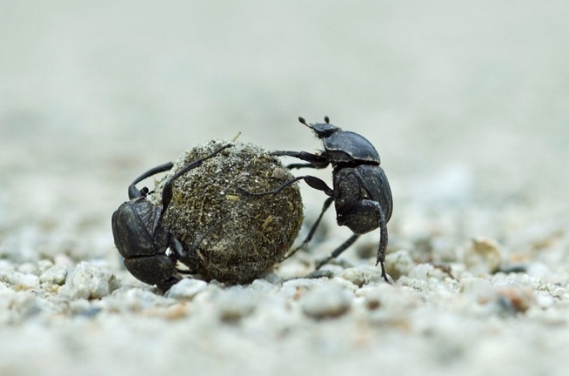

Tutor: I love biology. Just love it.
Student: Biology?
Yes. You know.
Not really. What’s biology?
The study of living things.
The study of living things?
The study of the natural world.
Oh. OK.
I think it’s fascinating.
Well yes. It is.
The other day I read about an insect, for example.
Really? Which insect?
The dung beetle.
The dung beetle?
Yes. I’m really into them now.
Why? What’s so cool about dung beetles?
Well, where should I start?
Start at the beginning.
How do you mean?
The beginning. Start there.
The beginning?
That’s always a good place to start.
Are you taking the Mick?
Oh no. Of course not.
Hmmmmm…
No, really.
Well …
Start from the beginning, and tell me about the dung beetle.
OK then. Let’s start with the name.
The dung beetle?
Well, that’s its common name.
Its common name? How do you mean?
In English. Its name in English.
Oh, right.
Its common name in English is “dung beetle”.
But all living things have a Latin name as well, right?
Two, in fact.
Two names?
A family name and a species name.
Like we do.
Yes. Like we do.
Our Latin family name is Homo.
That’s right. It means man.
We belong to the family of Homo.
Right.
The family of man.
And Sisiphus is the family name for dung beetles.
In Latin. That’s the Latin family name.
Yes. The scientific name.
Are there different kinds of dung beetle?
Loads. But they’re all in the same family.
So they all have the same family name?
Yes. Sispihus.
We have a Latin family name too.
Yes. It’s Homo. Latin for man.
Yes.
We’re the family of man.
I know. You just said that.
Oh. So I did.
The full scientific name for us is “Homo sapiens”.
Yes.
And it means “the man who thinks”.
“Homo” means “man” and “sapiens” means “thinking”, I suppose?
Yes. In Latin.
Our scientific name is often written as H. sapiens.
H. stands for Homo. Our family name.
Yes. I know.
But sapiens is the name of our species.
So our full scientific name is H. sapiens.
Homo sapiens.
The man who thinks.
We both know all that. Let’s get back to the dung beetle.
Mmmm...?
Well, you haven’t told me anything about it yet.
Oh. No. I suppose not.
So? What about the dung beetle?
Well, the dung beetle’s family name is Sisiphus.
I know that. But why are dung beetles called Sisiphus?
It comes from an ancient Greek myth.
What’s it about?
Well, it’s about a Greek King from thousands of years ago.
A Greek King from thousands of years ago?
Yes. His name was King Sisiphus.
OK. Tell me about this King.
Well, dung beetles take their family name from King Sisiphus.
Why?
It’s a long story.
Yes?
Quite a long story, anyway.
Yes?
It’s a long story, but quite an interesting one.
Yes?
A very interesting story, in fact.
Yes?
In spite of being so long.
Really?
I think so, anyway.
OK.
And it’s not even all that long.
No?
No. It’s not really long at all.
Right.
Shall I tell you it?
What? Yes! Get on with it! Before my head explodes!
Well, Sisiphus was a King thousands of years ago.
A Greek King. I know.
Really?
You just told me. Sisiphus was a Greek king, thousands of years ago. You just said.
Oh. So I did.
And?
Well, he was a bit naughty.
How do you mean “he was a bit naughty”?
Well, it’s only a myth of course.
I know that.
Just a story.
Yes. I know it’s only a story. I know what a myth is! But what happened?
Well, you know Hades was King of the underworld?
Hang on. What was the underworld?
The kingdom of the dead.
The kingdom of the dead? How do you mean?
It’s where you went when you were dead.
Where you went when you were dead?
It’s where the souls of the dead lived.
Well, that’s what they thought, I guess.
Yes.
In ancient Greece. That’s what they thought in ancient Greece.
Yes.
Right. And Hades was King of the underworld?
Yes
OK. But what does this have to do with dung beetles?
Well, Sisiphus got talking to Hades one day.
He got talking to Hades? That’s scary!
And Sisiphus played a trick on Hades.
Played a trick on the King of the dead?
Yes.
That wasn’t very clever!
No. Not at all clever.
So what was the trick he played?
Well, Hades had some golden handcuffs.
Handcuffs for the dead?
To get them into the underworld, I suppose.
Right. What then?
He got Hades to show them to him.
He’s a bit silly, this King!
Silly?
Well, you can see what’s going to happen next.
Can you?
He gets Hades to put them on, doesn’t he?
Well, yes. That’s right! He gets Hades to put his own handcuffs on.
Which probably made him cross.
Hades? Yes, I expect so.
Very cross indeed, I expect.
Yes. It did.
Not very clever!
No. You should never annoy the king of the underworld. Remember that.
And now he can’t take the dead down to the underworld.
No. He’s handcuffed.
He’s in his own handcuffs!
That’s exactly right. he was stuck. Nobody could die.
Awesome!
Well, it got to be a real problem.
Really?
So the story says, anyway. The dead queuing up to go into the underworld.
So I suppose the King had to let Hades go, in the end?
Yes.
I bet Hades was cross.
You bet he was!
I bet he remembered Sisiphus, too.
He did.
He probably wanted to pay him back.
Yes. He did.
And even a King has to die, one day.
Yes. And one day, of course, he did.
And Hades was waiting for him.
You’re right. He was!
Oops!
Exactly! Oops!
What did Hades do to him?
To Sisiphus?
Yes.
He had a special punishment for him.
What was that?
He made him roll a rock up to the top of a hill.
That wasn’t so bad.
It was, actually.
Why?
Because Sisiphus never gets the rock to the top of the hill.
Never gets it to the top of the hill?
No. Not quite.
How’s that?
He has to do it over and over again.
For ever and ever?
Yes.
Why?
Because every time he gets it near the top, it slips.
And rolls back down?
Right.
And he has to start all over again?
Yes.
So he has to roll a rock up a hill for ever and ever?
That’s right.
Poor King.
Yes, poor Sisiphus.
Where does the dung beetle come in, then?
Oh yes.
The dung beetle named Sisiphus.
Yes. After a Greek King.
Yes, but why is the dung beetle named Sisiphus? You still haven’t told me.
Well, a dung beetle lays one egg at a time.
Right.
And it immediately wraps it up.
Does it?
In a lump of dung.
Really? Wraps it up in a lump of dung?
Yes.
Why would it do that?
To hide it I suppose.
Oh.
And maybe provide food for the egg.
For when it hatches?
Yes.
How does the beetle wrap its egg in a lump of dung?
Well that’s the whole point of the story, you see.
That’s where Sisiphus comes in, is it?
Yes.
How?
Because the beetle rolls a little bit of dung round and round and round.
Until it is a little ball, I suppose.
Yes. A little ball of dung.
With an egg hidden in the middle, I guess.
Yes.
And this makes people think of Sisiphus?
Yes. They think of King Sisiphus rolling his rock up the hill.
The beetle rolls its lump of dung round and round and round.
Working really hard.
And it looks like King Sisiphus rolling his rock.
Working really hard.
And I suppose dung beetles lay loads of eggs?
Yes. They do. Loads of eggs.
And they hide every egg in a ball of dung.
Yes.
So dung beetles spend a lot of time rolling balls of dung around.
Yes. They do.
Right.
In some parts of the world it’s very common.
To see dung beetles rolling balls of dung?
Yes.
They must seem to spend all their time rolling dung balls.
Exactly.
They must seem to roll dung balls for ever and ever.
Yes. Just like Sisiphus.
Rolling his rock.
Which is why the family name for dung beetles is Sisiphus.
Rolling his rock for ever and ever.
Yes.
Like a dung beetle rolling a dung ball.
Yes. Exactly like that!

(In memory of Duggie Lees who taught biology all those years ago. His light still shines bright and clear.)

